USING A GRAPHING CALCULATOR NOTES
Always do first:

KEYS:

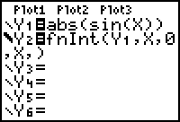

KEYS:

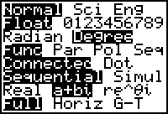

KEYS:

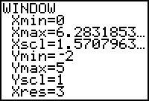

KEYS:

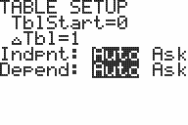

KEYS:

ENTERING DATA:
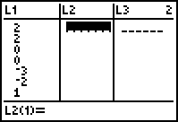
Clear lists first

KEYS:

Add data to list-use L₁ and L₂ (if possible)
- Move cursor to data line under L₁
- Enter number-press enter
- Continue until all data is entered
- Repeat with L₂

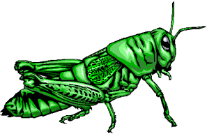
Pierce (1948) mechanically measured the frequency (the number of wing vibrations per second) of chirps (or pulses of sound) made by a striped ground cricket, at various ground temperatures. Since crickets are ectotherms (cold-blooded), the rate of their physiological processes and their overall metabolism are influenced by temperature. Consequently, there is reason to believe that temperature would have a profound effect on aspects of their behavior, such as chirp frequency. In general, it was found that crickets did not sing at temperatures colder than 60º F. or warmer than 100º F.
Chirps/Second | Temperature
20 | 88.6
16 | 71.6
19.8 | 93.3
18.4 | 84.3
17.1 | 80.6
15.5 | 75.2
14.7 | 69.7
15.7 | 71.6
15.4 | 69.4
16.3 | 83.3
15 | 79.6
17.2 | 82.6
16 | 80.6
17 | 83.5
14.4 | 76.3

Create a Scatterplot:
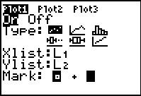
Set Plot 1

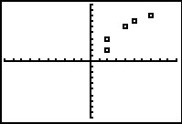
To see your data on the graph you may need to zoom
KEYS:

Use the Trace feature to move the cursor from point to point
Clear your lists and try another set of data:
Hours Spent Studying | Math SAT Score
4 | 390
9 | 580
10 | 650
14 | 730
4 | 410
7 | 530
12 | 600
22 | 790
1 | 350
3 | 400
8 | 590
11 | 640
5 | 450
6 | 520
10 | 690
11 | 690
16 | 770
13 | 700
13 | 730

