Unit 2 Skills Review Name_____________________________

1.Using the data given in the table to the left, make a scatterplot. Label the
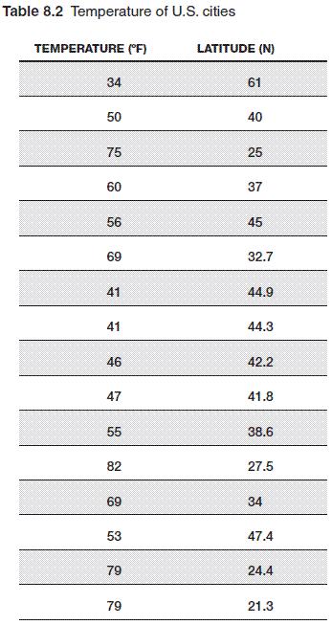
axes appropriately.

2. What type of correlation does the data show?

3. Draw in the line of best fit. Find the equation for your line.

4. Interpret the slope and y-intercept of your line for this problem.

5. Examine the data. Is your line reliable? Are there any outliers? Is there any clustering? Explain.

6. Construct a two-way table from the following Venn Diagram.
Sport

Foreign Language

14
23
25
5

7. Construct a two-way table from the given information.
Felipe surveyed students at his school. He found that 88 students own a cell phone and 67 students own an MP3 player. There are 23 students that do not own a cell phone, but own an MP3 player. Nineteen students do not own either device.

8. From the above information, what is the relative frequency of students who own a cell phone?

