Name_____________________________

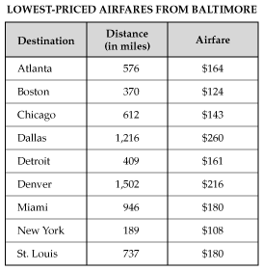
1.Using the data given in the table to the left, make a scatterplot. Label the
axes appropriately.

2. What type of correlation does the data show?

3. Draw in the line of best fit. Find the equation for your line.

4. Interpret the slope and y-intercept of your line for this problem.

5. Examine the data. Is your line reliable? Are there any outliers? Is there any clustering? Explain.

6. Construct a two-way table from the following Venn Diagram.
Sport

Foreign Language

34
27
30
7

7. Construct a two-way table from the given information.
Felipe surveyed students at his school. He found that 85 students own a cell phone and 64 students own an MP3 player. There are 20 students that do not own a cell phone, but own an MP3 player. Sixteen students do not own either device.

8. From the above information, what is the relative frequency of students who own a cell phone?

