GRAPHING CALCULATOR ASSIGNMENT Name_____________________________
Sandwich | Total Fat (g) | Total Calories
Hamburger | 9 | 260
Cheeseburger | 13 | 320
Quarter Pounder | 21 | 420
Quarter Pounder with Cheese | 30 | 530
Big Mac | 31 | 560
Arch Sandwich Special | 31 | 550
Arch Special with Bacon | 34 | 590
Crispy Chicken | 25 | 500
Fish Fillet | 28 | 560
Grilled Chicken | 20 | 440
Grilled Chicken Light | 5 | 300
1.
Is there a relationship between the fat grams and the total calories
in fast food?
Use your graphing calculator to make a scatterplot and line of best fit for the data. Sketch your graph below.

List your window here:
Answer the question posed and explain.
2. Graph the scatterplot and line of best fit.

Fifteen athletes trained for the 100m sprint for the Mathopolis Games. Some of them took their training more seriously than others. The following table gives the number of days training and the times taken to run 100 m in the Mathopolis Games.
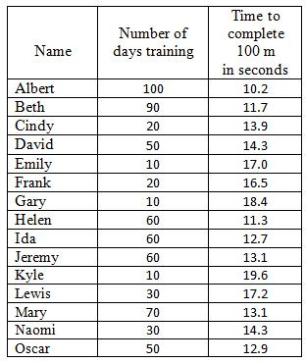
Sketch of scatterplot with line of best fit: Window:

