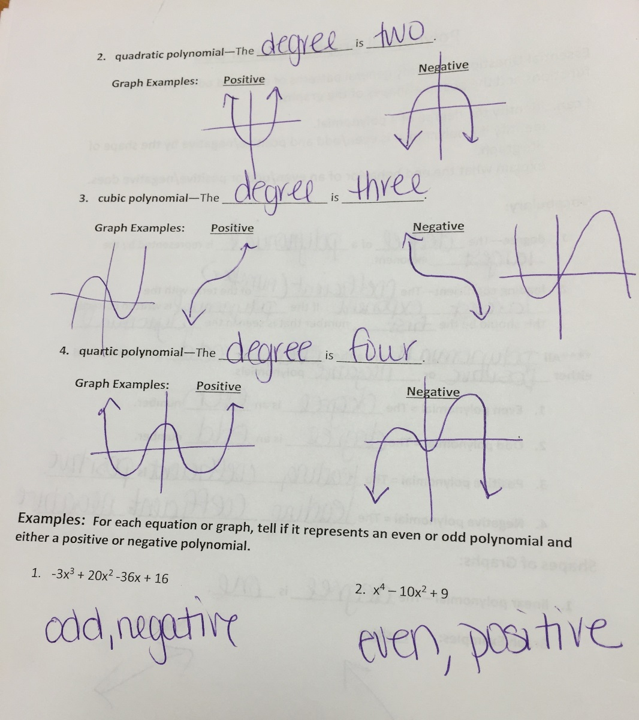
You should notice that for a degree of 2 there are 2 roots (x-intercepts), degree 3 has 3 roots, etc.

For the examples, number 1 has an exponent of 3odd and a leading coefficient of -3negative. Number 2 has an exponent of 4even and a leading coefficient of 1positive.
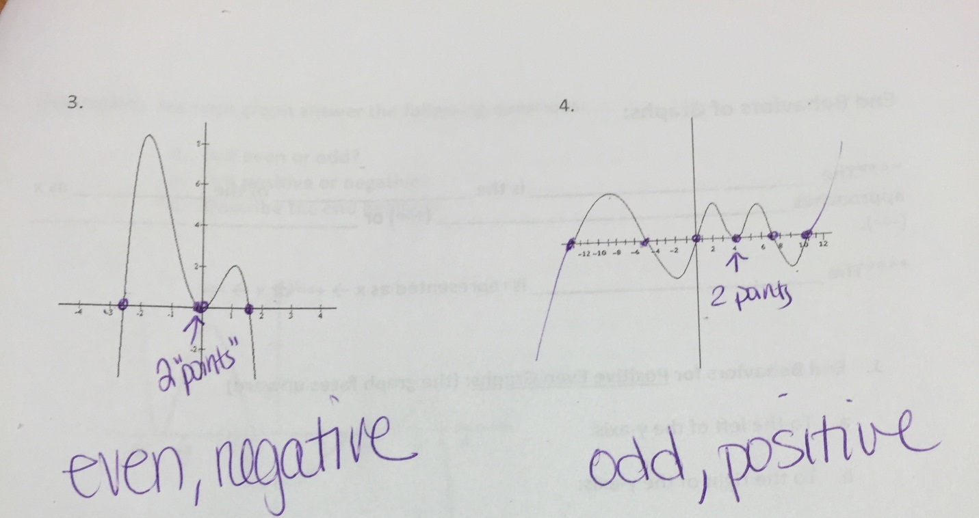
You should notice the number of times that the graph turns.
Example 3 turns 3 times so the minimum the degree can be is 4. You then need to look at the number of x-intercepts. Since the middle one doesn’t cross but sits on the x-axis it is a double root (counts as 2). If you count the number of roots, you have 4 making the degree 4. Since it ends (on the right) going down, it is negative.
Example 4 turns 6 times so the minimum the degree can be is 7. You then need to look at the number of x-intercept. Since the 4th one sits on the x-axis it counts as 2. If you count the roots, you have 7 making the degree 7. Since it ends going up, it is positive.

